**CIS 572 Object Oriented System Design**

**Backward Tracing**

for

**Report Extraction**



Submitted to:  Mr. Thomas Steiner

~~Submitted by : Kopal Shinde~~

~~UMID 20780248~~

**Table of Contents**

CRC CARD **3**

STATE DIAGRAM **3**

DFD **4**

CLASS DIAGRAM **5**

SEQUENCE DIAGRAM **6**

COMMUNICATION DIAGRAM **7**

ROBUSTNESS DIAGRAM **7**

BUILD ERD **8**

USE CASE DIAGRAM **8**

USE CASE FLOW **9**

# CRC CARD

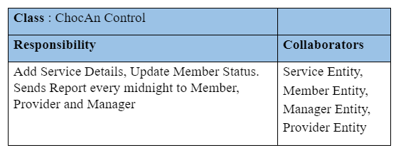

# STATE DIAGRAM

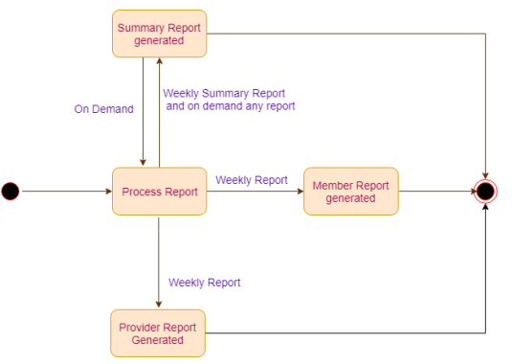

# DFD

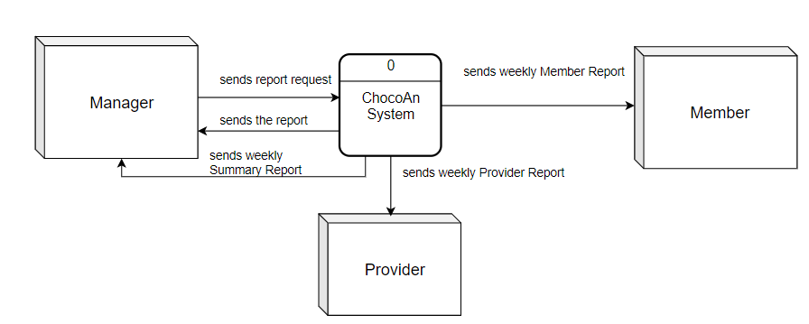

# CLASS DIAGRAM [diagram below was deleted]

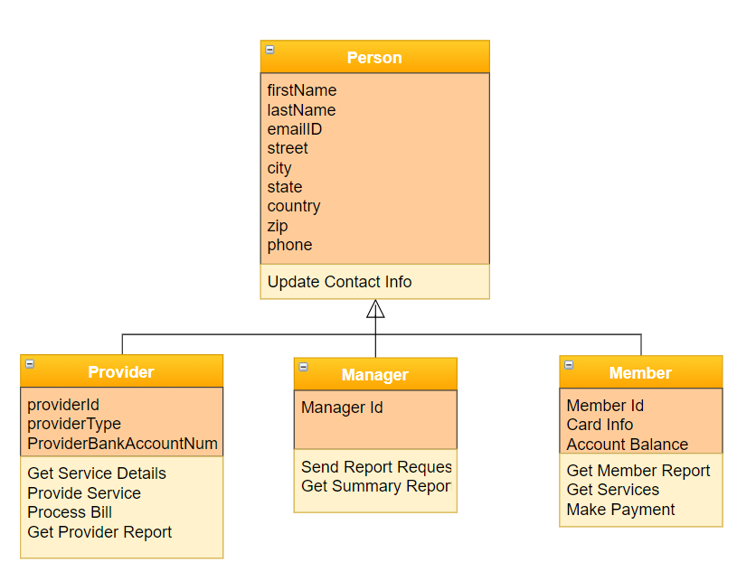

# SEQUENCE DIAGRAM

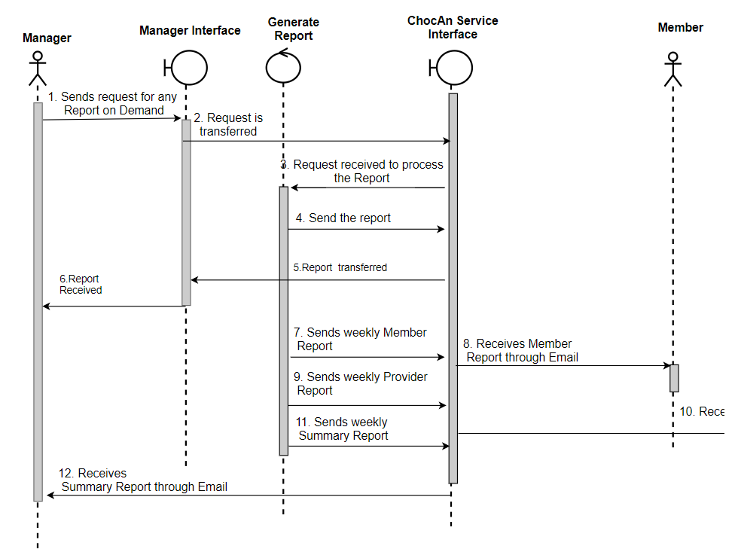

# COMMUNICATION DIAGRAM

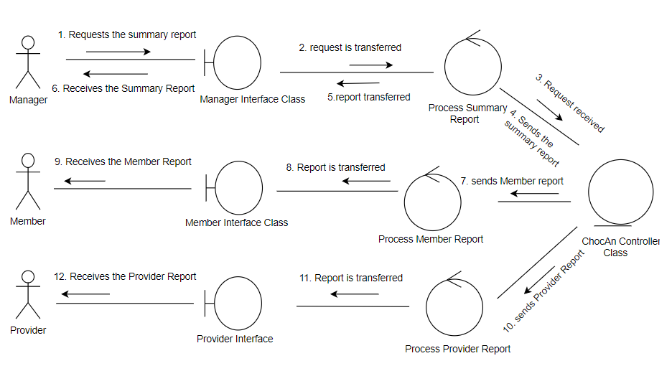

# ROBUSTNESS DIAGRAM

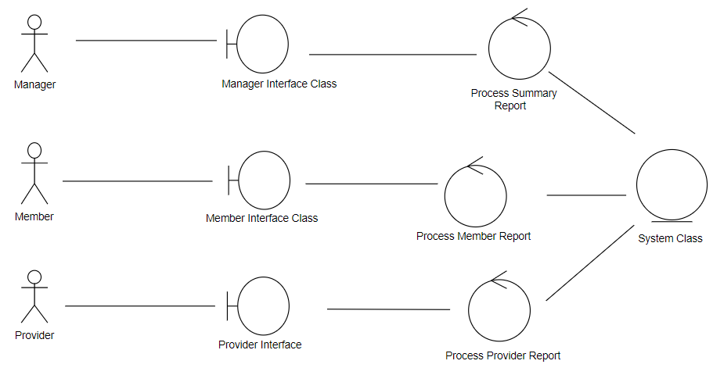

# BUILD ERD

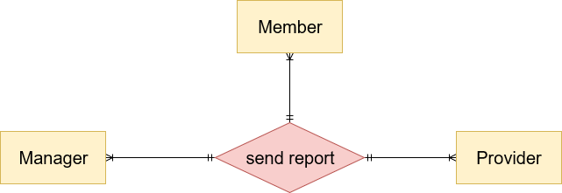

[diagram below was deleted]

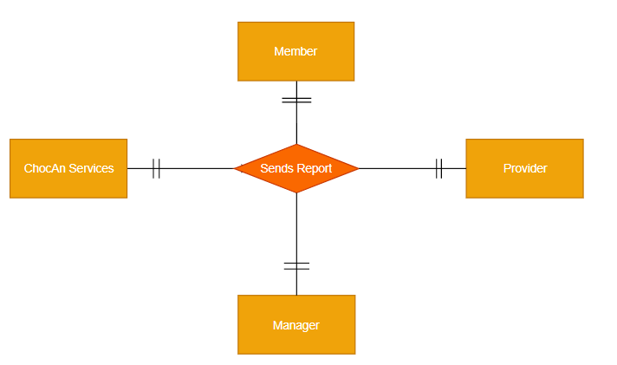

# Swimlane Diagram

# ~~USE CASE DIAGRAM~~ [diagram below was deleted]

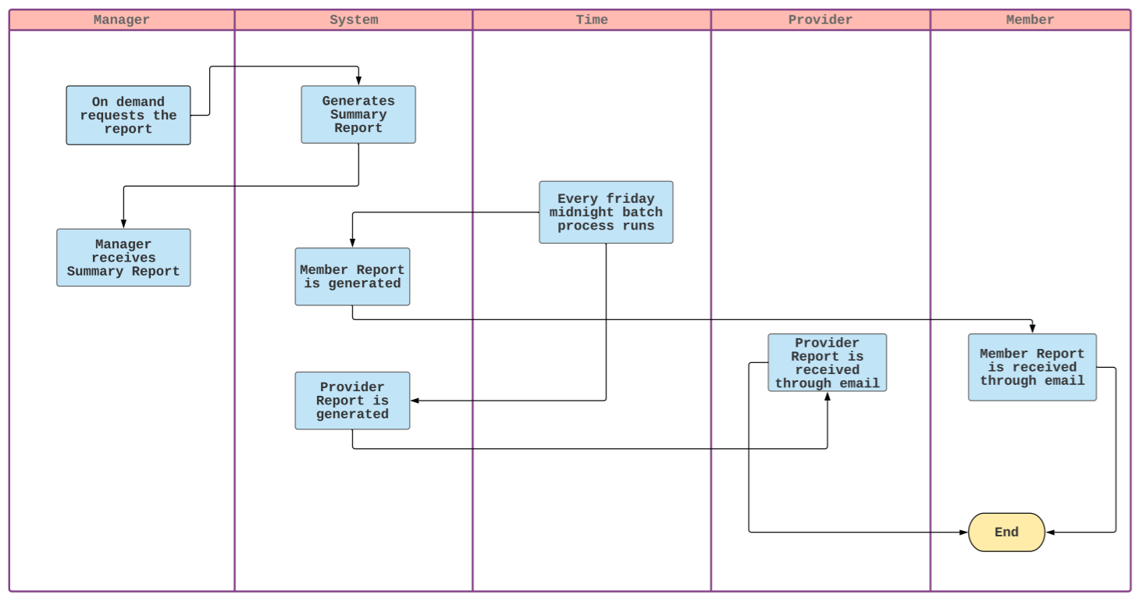

# USE CASE DIAGRAM

# 

# USE CASE FLOW

**7.2** Provider receives the Provider Report:

1. The reports are generated weekly having the details on service provided by the provider and fees.
2. The provider report is sent as an email to the provider.

## 

# 

# 

# 